**Project 1 - Phase ___2___**

**Name: _Gowrishankar Dakshnamurthy _**

**Email: _gdakshnamurthy@horizon.csueastbay.edu_**

**Section 1 Execution Instructions:**

*After downloading the zip file from blackboard in to a specific destination in your computer, open Eclipse, go to file-> Import, select “Existing project in to workspace” option. Click on select archive file radio button and browse for the downloaded zip file by clicking on browse button and select the zip file then press finish. The project would import as ImageApplication. Run the project as java Application.*

/*FIGURE HERE  
**screenshot 1.2 = directory view of "temp" directory you unzipped file to showing the unziped files and directory structures**.

FIGURE HERE  
**screenshot 1.3 = Eclipse running where you have opened up project file in "temp" directory.**

FIGURE HERE  
**screenshot 1.4 = Eclipse running the application - show screenshot of it running. If I must do something beyond simply hitting the "run" button, you need to give screenshots and step by step instructions. */**

**Section 2 Code Description**

*A describing how code is structured and the state of how it works. Give a description for each filename listed.*

*ImageApplication.java – Consist of code to create a small window from where image files can be opened.*

*ImageData.java – Consist of code to render Image, and to create edge detection and contrast sketching.*

*ImageFrame.java – Consist of code to set a window frame and set the image in a window frame and code to manipulate that image.*

**Section 3 Testing**:

*here you give screen shots of you running the various stages of the program as detailed here:*

**section 3.1: loading image** -   
  
  
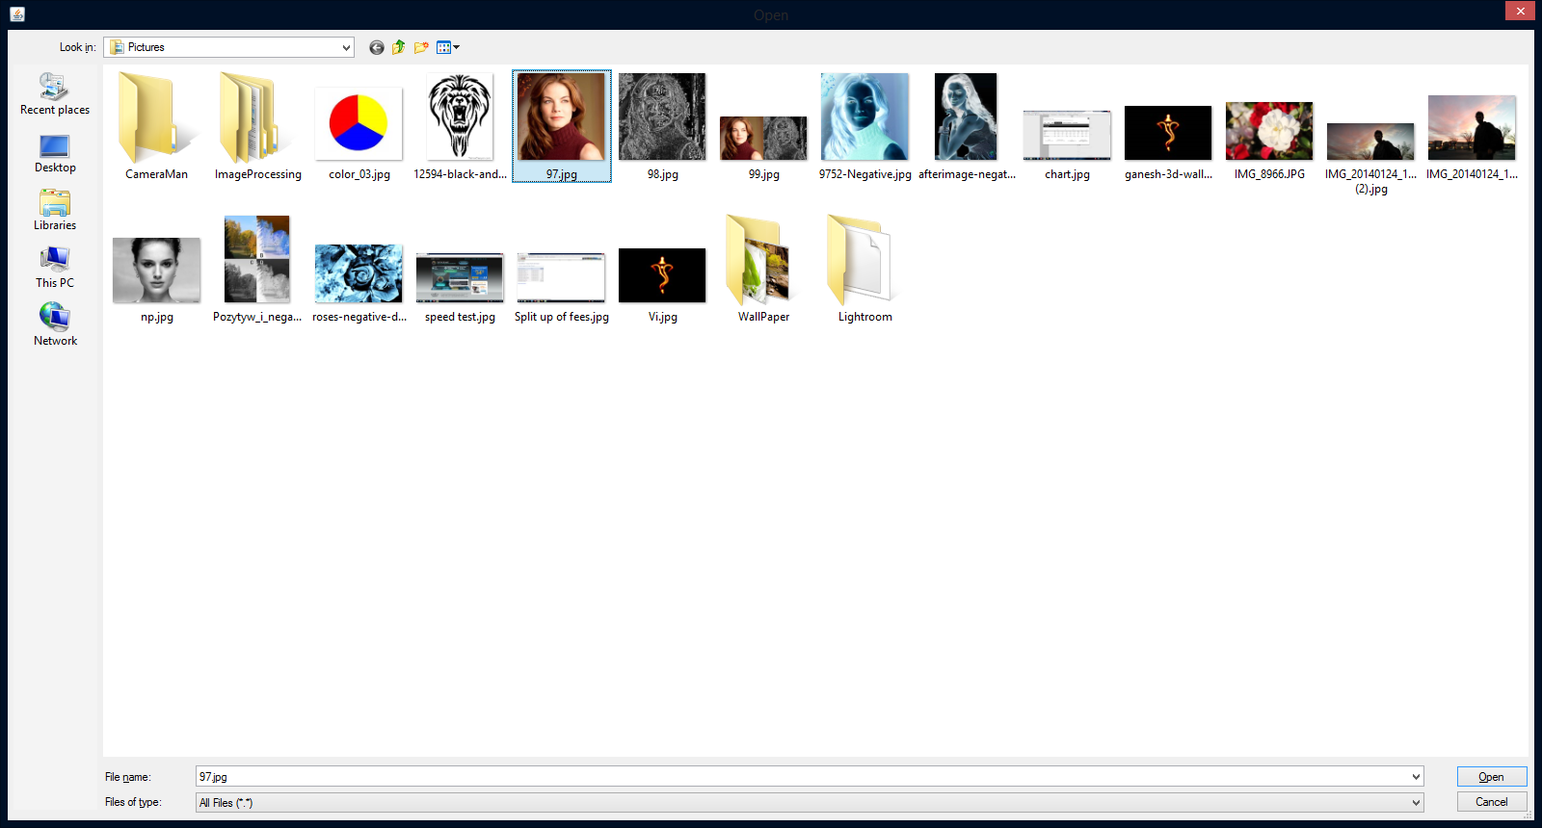  
screenshot 3.1a= pop-up file dialog box where you have selected the image you are going to load in your program.

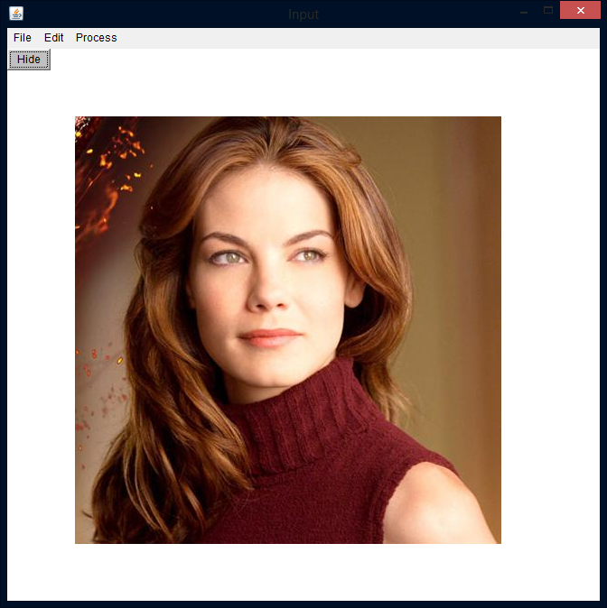  
screenshot 3.1b= the image being viewed in your application that was just loaded.

**section 3.2: saving image**

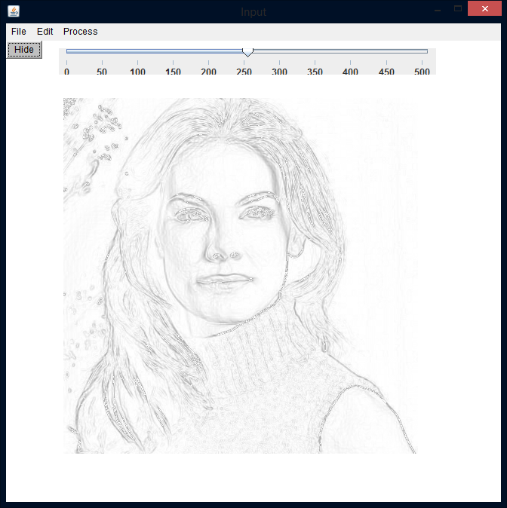  
screenshot 3.2a = screen shot of active image in your application you are going to save

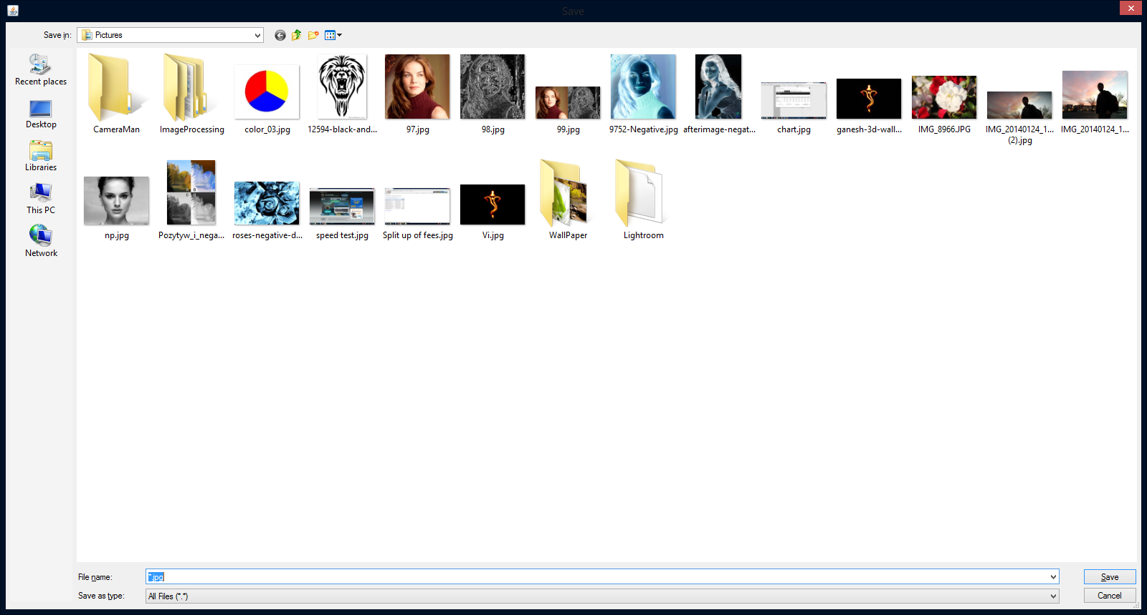

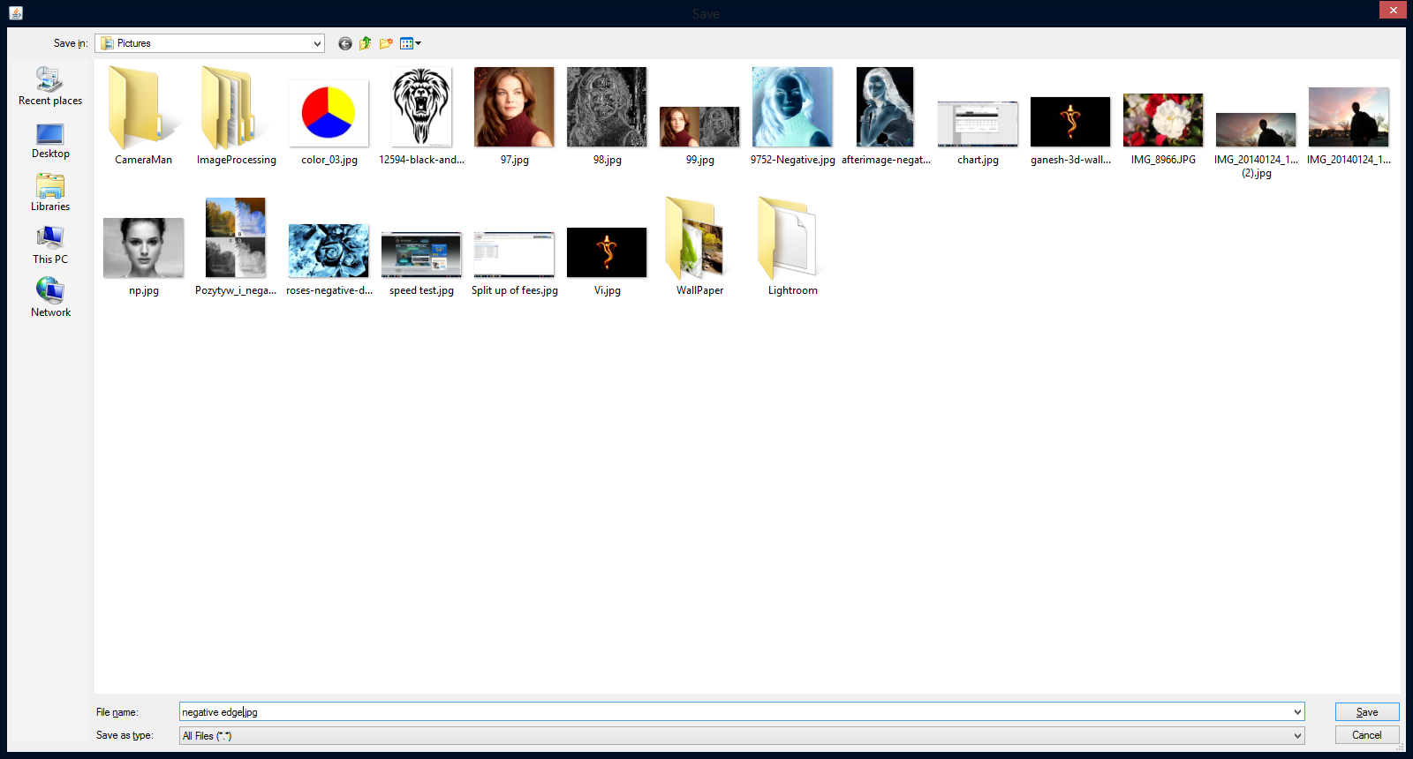  
screenshot 3.2b = screen shot of file save as dialog box where you have specified a DIFFERENT name not used yet for this image.

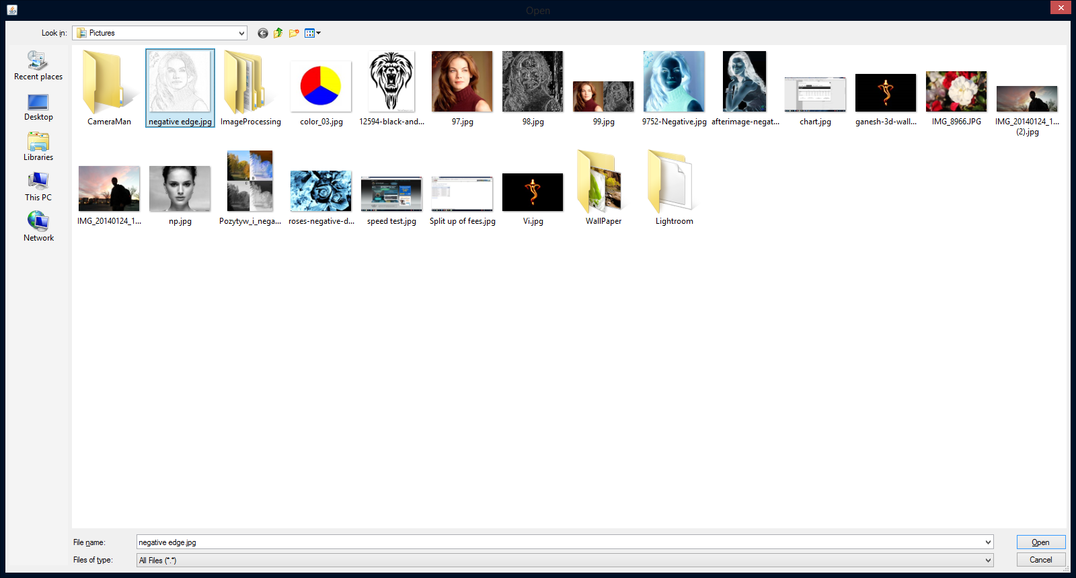

screenshot 3.2c = screen shot after you do an open on the image you just saved in 3.2b

**section 3.3: exit application**

FIGURE HERE  
screenshot 3.3a = screen shot showing application gone (really this is nothing) BUT, if the application has errors on closing I want to see this!!!

No error occurring in exiting the app.

**section 3.4: thresholding (PHASE 2 only)**

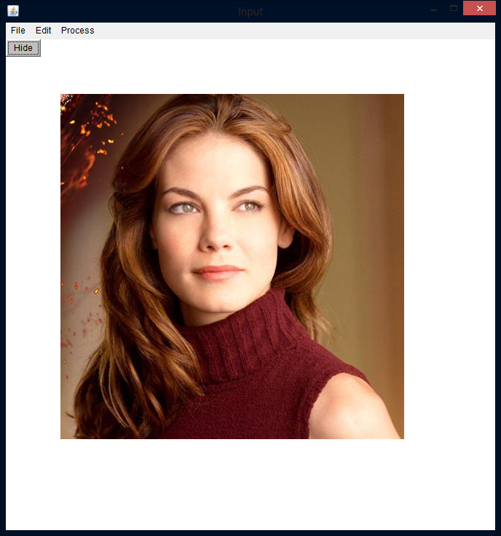  
screenshot 3.4a = original image you are going to threshold shown in activeimage displayed in your application

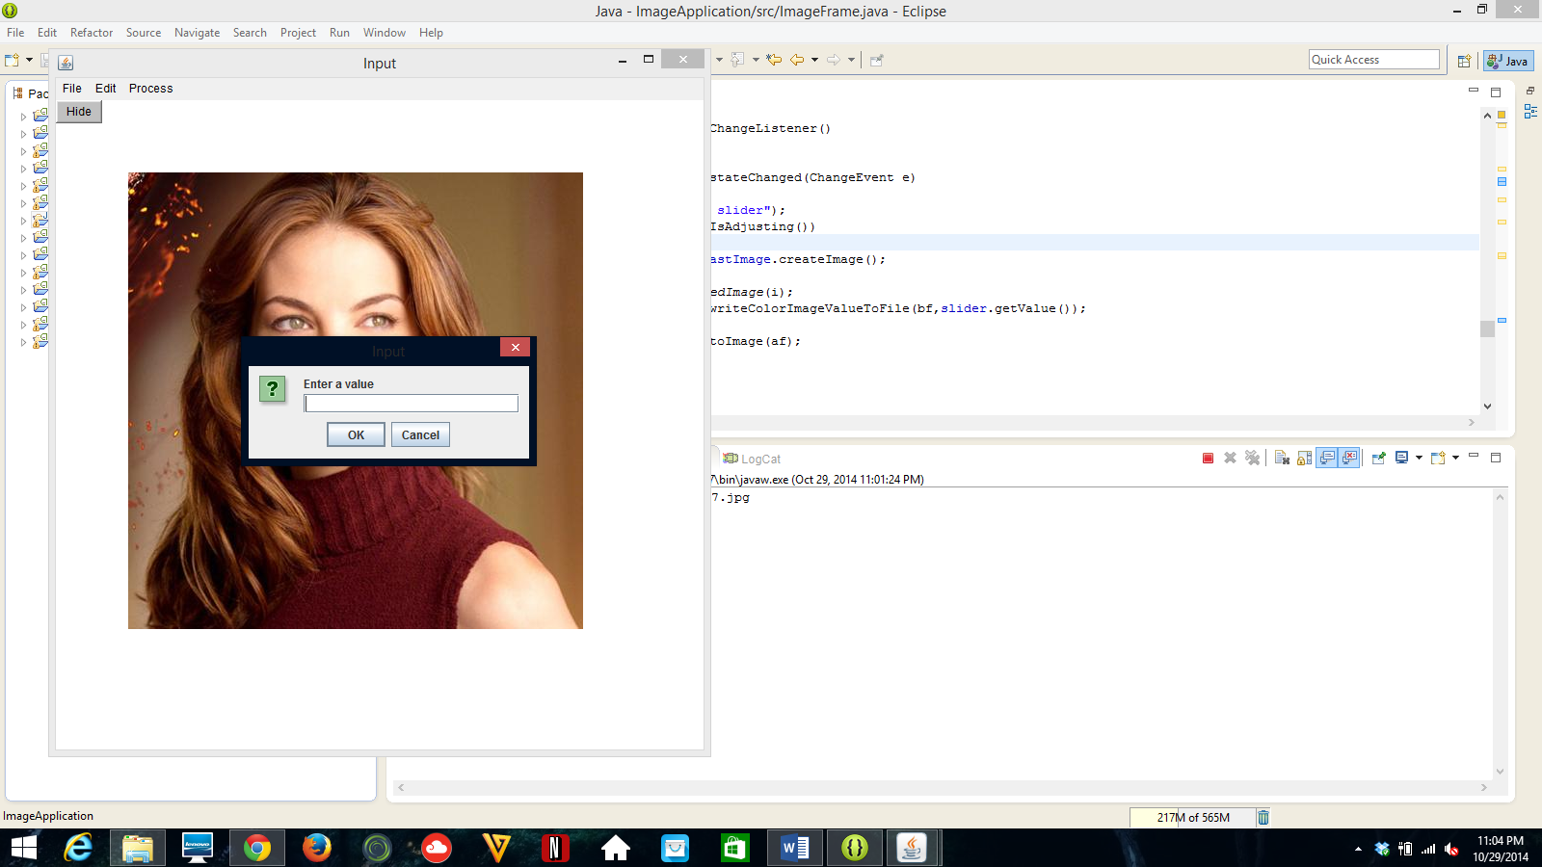  
screenshot 3.4b = pop-up dialog box asking user for threshold information, enter in the threshold value before screenshot

FIGURE HERE  
screenshot 3.4c = new image after thresholding in activeimage displayed in your applicaiton.

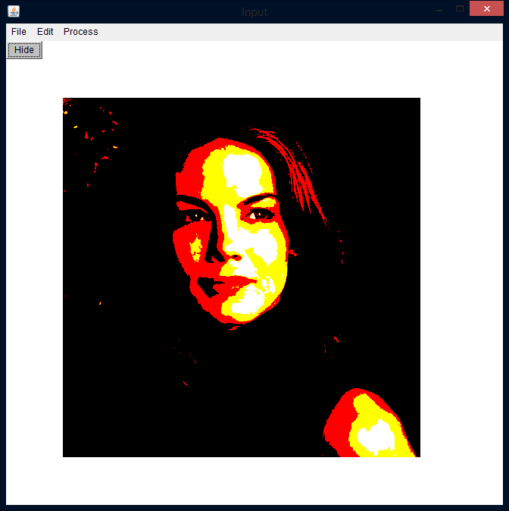

**section 3.5: Undo Operation (done in phase 1 but, shown in Phase2)**

  
screenshot 3.5a = thresholded image from screenshot 3.4c.

  
screenshot 3.5b = new image reverting back to unthresholded image AFTER you have selected the UNDO operation. This is the new activeimage displayed in your application.

**section 3.6: negative (PHASE 2 only)**

  
screenshot 3.6a = original image you are going to negate shown in activeimage displayed in your application

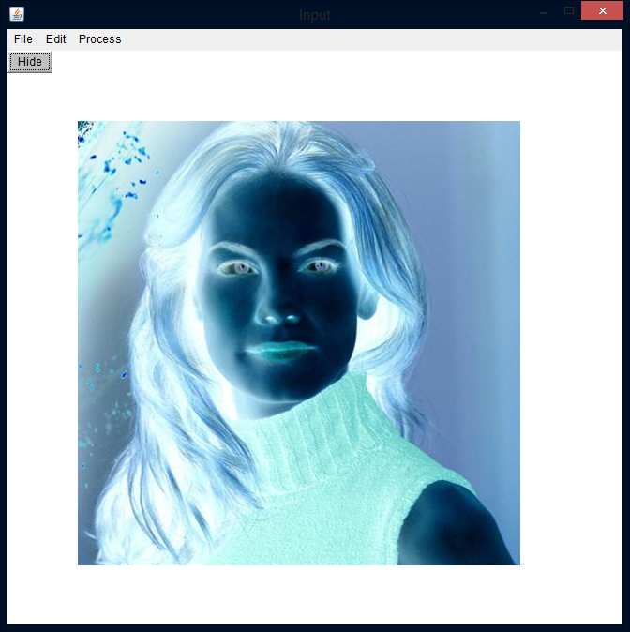  
screenshot 3.6b = new image after negative operation done in activeimage displayed in your applicaiton.

**section 3.7: edge detection (PHASE 2 only)**

  
screenshot 3.7a = original image you are going to edge detection on shown in activeimage displayed in your application

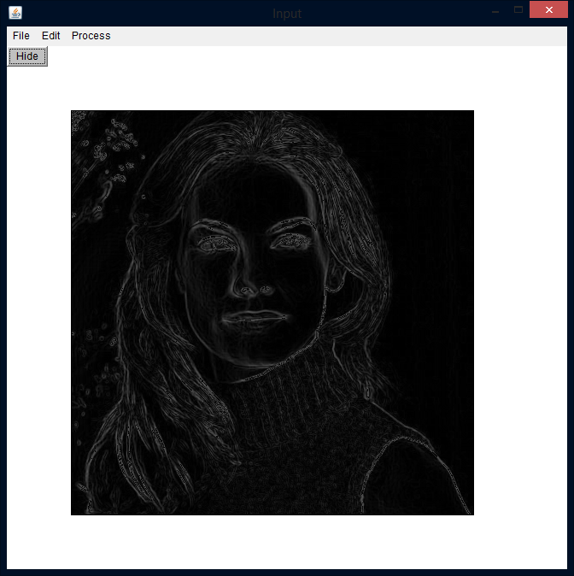  
screenshot 3.7b = new image after edge detection done in activeimage displayed in your applicaiton.

**section 3.8: contrast stretching (PHASE2 only)**

  
screenshot 3.8a = original image you are going to contrast stretch shown in activeimage displayed in your application

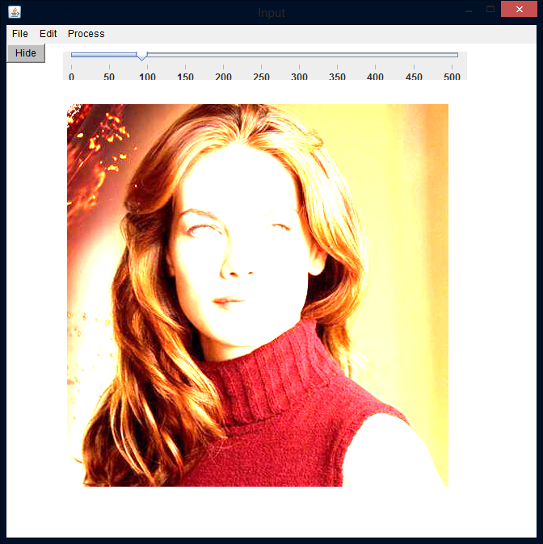screenshot 3.8b = As slider is there user can use slider to change contrast value. Above is image when contrast value is less.

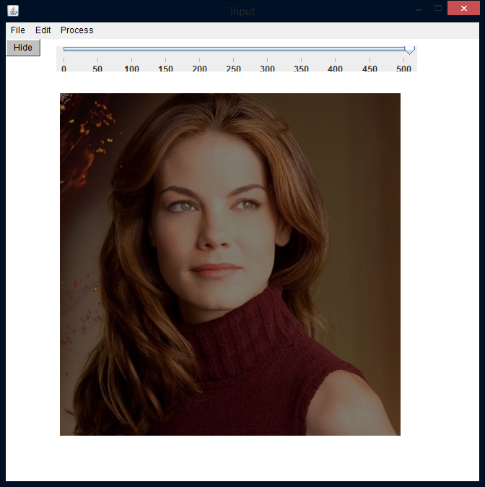  
screenshot 3.8c = As slider is there user can use slider to change contrast value. Above is image when contrast value is more

**Section 4 Comments**

Optional any comments you have regarding your code (necessary if you code is not working, you need to tell me in detail what the problem is or what is missing)